# Table of Contents

**Network-as-a-Service Runbook**

***Transport & IP Network Reference Architecture***

**<NaaS Operator’s Name>**

**

*<Release Date>*

Table of Contents 1

1 Document Control 3

2 About Design Template 4

2.1 Document Purpose 4

3 Executive Summary 4

4 Introduction 5

5 Transport Technologies Selection 5

5.1 Fiber Optic Transport Architecture 5

5.2 Microwave Transport Architecture 5

5.3 Satellite Transport Architecture 6

6 IP Networking Design 6

7 High-Availability 7

7.1 Redundancy and Fault Detection Mechanisms 8

8 QoS Mapping and Scheduling Considerations 8

9 Additional Architectural Design Considerations 8

9.1 Synchronization 8

9.2 Security 8

# Document Control

- Revision Control sheet allows to maintain a record of changes made on the document.

|  |  |  |  |
| --- | --- | --- | --- |
| Version N° | Issue Date | Status | Reasons for Change |
|  |  |  |  |
|  |  |  |  |
|  |  |  |  |
|  |  |  |  |

Table 1. Revision History

# About Design Template

## Document Purpose

The purpose of this document is to provide a baseline document that NaaS operators can use to define the overall architecture of the Transport & IP Network.

The document comprises the following sections. Section 4 provides an overview of the overall Transport & IP Network Architecture. Section 5 defines the architecture considerations for different transport technologies, both terrestrial and non-terrestrial. Section 6 describe the IP Network Design considerations. In Section 7, the description of the different mechanisms to achieve a high-availability network are provided. The Section 8, the mechanisms regarding QoS and Schedule are described. Finally in Section 9, the definition of additional architectural considerations are provided.

In each section, the customizable options are provided with the following format. This options must be attended accordingly and deleted of the final version of the document.

# Executive Summary

This document is intended to define the technical design features in the Transport & IP Network of the *<NaaS Operators’ Name>* to support the implementation on 4G LTE mobile services.

# Introduction

In a mobile environment, the Transport Network interconnects different networks including the RAN (Radio Access Network), data centers and external networks.

The Transport network architecture is shown in Figure 1.

*Use the output of the Wizard for Tx & IP Architecture to determine the Transport & IP Architecture to be implemented and update this part of the section.*

# Transport Technologies Selection

This section describes the architecture of the different transport technologies to be used on the transport network.

## Fiber Optic Transport Architecture

*This sections specifies the considerations when Fiber Optic is used as transport technology. If the NaaS operator will not consider Fiber optic as an available option, delete this section.*

The general architecture using Fiber Optic as a transport technology is displayed in Figure 2. In this scenario, the enodeB is connected to a router located at the site, commonly named as Cell Site Gateway (CSG), which provides the transport services. The CSG is connected through a Fiber Link to the aggregation Node located in the transport node, which sends the traffic to the Mobile Core. Alternatively, an L2 switch can be deployed on the cell site location, moving the CSR location to the aggregation node.

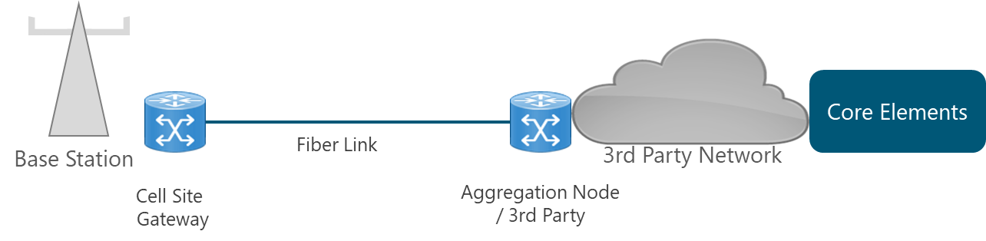

*Figure 2. Transport Architecture using Fiber Optic*

*Complement the section with the specifications provided in the Section 4.1.1 of the Tx & IP Architecture Module according with the type of scenario(s) implemented and NaaS operator conditions:*

* *Fiber Construction*
* *Fiber Link Leasing*
* *No Fiber Links*

## Microwave Transport Architecture

*This sections specifies the considerations when Microwave is used as transport technology. If the NaaS operator will not consider Microwave as an available option, delete this section.*

The general architecture using Microwave as a transport technology is displayed in Figure 3. In this scenario, the eNodeB is connected to the radio equipment located in the site, which is connected through a MW Link to the radio equipment located in the transport node. Then, a connection to the aggregation node is reached which sends the traffic to the Core elements.

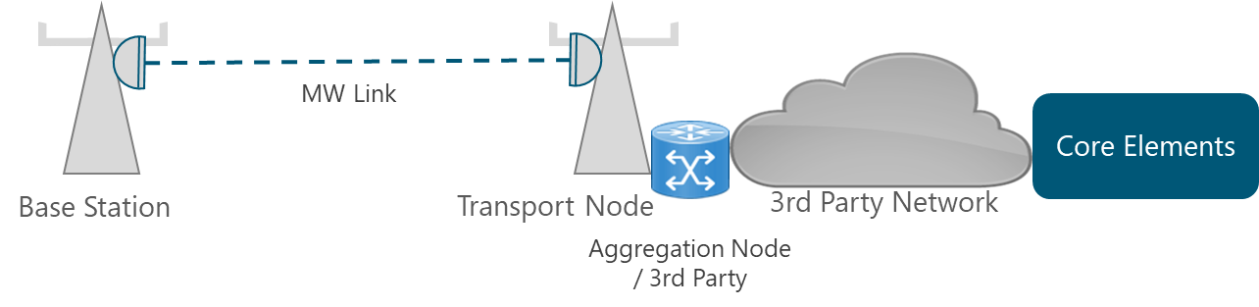

*Figure 3. Transport Architecture using Microwave*

*Complement the section with the specifications provided in the Section 4.1.2 of the Tx & IP Architecture Module according to NaaS operator conditions.*

## Satellite Transport Architecture

*This sections specifies the considerations when Satellite is used as transport technology. If the NaaS operator will not consider Satellite as an available option, delete this section.*

The Architecture using Satellite as a transport technology is displayed on Figure 4. In this scenario the eNodeB is connected to a Very Small Aperture Terminal (VSAT) located in the site, which is connected through a Satellite Link to the terrestrial Satellite Hub. From this point, a connection to the aggregation node is reached which in turn, sends the traffic to the Core elements.

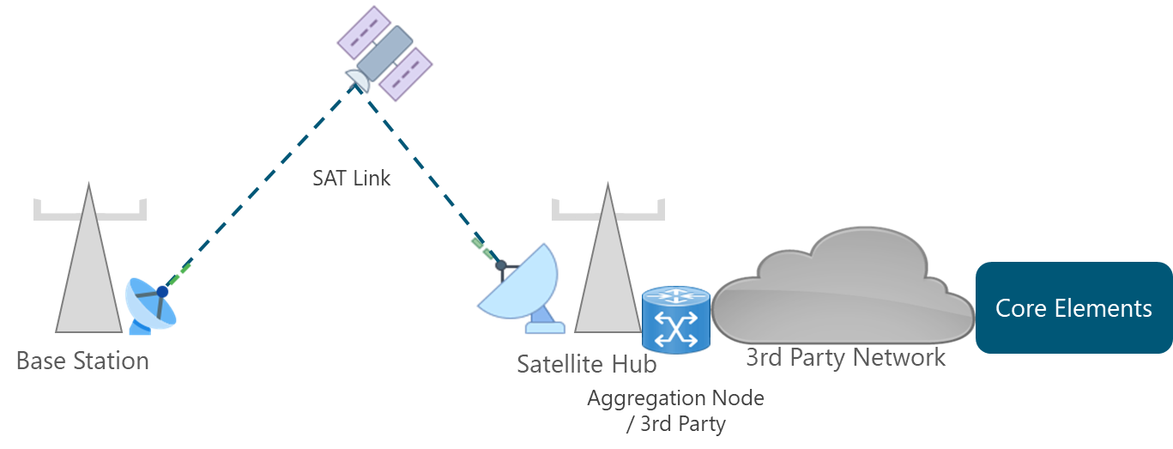

*Figure 4. Transport Architecture using Satellite*

*Complement the section with the specifications provided in the Section 4.1.3 of the Tx & IP Architecture Module according to NaaS operator conditions.*

# IP Networking Design

Long-Term Evolution (LTE) defines a flat network architecture that eliminates the radio controllers. Thus, controller functions are redistributed to the core elements and the base stations (eNodeB).

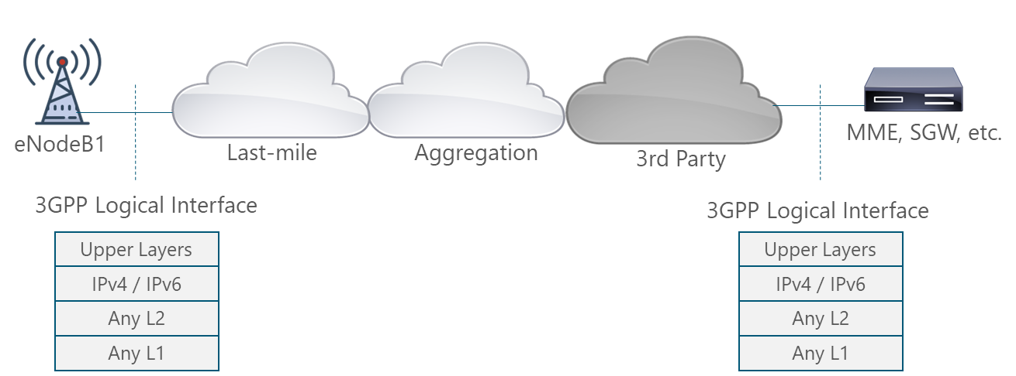

*Figure 5. 3GPP Logical Interfaces Protocol Stack*

In order to support the scenario presented in Figure 5, the following protocols are implemented in the different segments and layer of the network transport.

*Use the output of the Wizard for Tx & IP Architecture to determine the Protocols in each segment and layers and update this part of the section.*

# High-Availability

Availability of the transport network is the proportion of time that the network is in functioning condition. The Figure 6, displays the availability value definition for the different network segments.

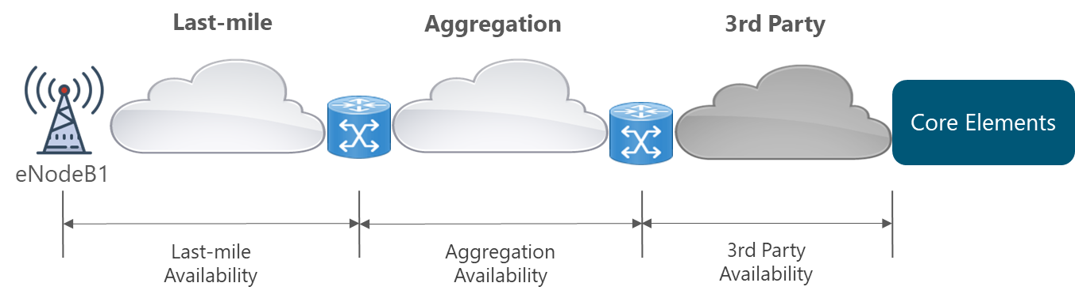

*Figure 6. Availability definition on each segment of transport network*

The defined Availability values must be fulfilled in all network segments and they must be considered during the Design phase.

The established values for the different segments within the NaaS transport network are presented in Table 2.

|  |  |
| --- | --- |
| Service Level | Availability (%) |
| Last-mile Link | 99,9% |
| Aggregation Link | 99,99% |
| 3rd Party Network | 99,99% |
| Satellite Link | 99,9% |

*Table 2. Availability Requirements Definition*

*The values presented in Table 2 corresponds to default values of a typical rural NaaS operator, and they must be updated according to NaaS operator conditions.*

## Redundancy and Fault Detection Mechanisms

This section includes the diverse redundancy mechanisms, both physical and logical, as well as fault detection mechanisms to be implemented in the transport network.

*Use the output of the Wizard for Tx & IP Architecture to determine the Mechanisms to be implemented in each segment and update this part of the section.*

# QoS Mapping and Scheduling Considerations

The concept of QoS used in LTE networks is based on classes, where each type of traffic (e.g. data, voice, signaling) is assigned a QoS Class Identifier (QCI) by the network to ensure adequate QoS for traffic in the LTE network.

To allow separation of traffic in the transport network, translation of the radio QCI level into the transport QoS level is performed initially on the eNodeB. However, additional translations may be performed by intermediate transport devices along the path. For this reason, the QoS parameters in all the devices across the path must be correctly configured.

The traffic is classified and marked are performed by the eNode B for the Uplink traffic and by the Core elements for the Downlink traffic. Additionally, all the intermediate nodes must maintain the QoS markings.

The mapping function among QoS codes of different layers in the transport network is presented below.

*Use the QoS Mapping and Scheduling Template to define the QoS Mapping Function and update this section.*

The Scheduling mechanisms to be implemented in the transport network is presented below.

*Use the QoS Mapping and Scheduling Template to define the Scheduling Mechanisms and update this section.*

# Additional Architectural Design Considerations

This section provides guidance on the additional design considerations must be considered in order to support the overall Transport & IP Network solution.

## Synchronization

Synchronization is fundamental in the LTE network operation as a failure in synchronization can result in spectral inefficiency and service degradation. The types of synchronization methods of interest for a mobile network are phase/time synchronization and frequency synchronization.

The synchronization mechanisms to be implemented in the transport network are presented below.

*Use the output of the Wizard for Tx & IP Architecture to determine the Synchronization Mechanisms to be implemented and update this part of the section.*

## Security

The security mechanisms to be implemented in the transport network are presented below.

*Use the output of the Wizard for Tx & IP Architecture to determine the Security Mechanisms to be implemented and update this part of the section.*